UNIT 3

APPLICATIONS OF THE CNC MACHINES

I. READING COMPREHENSION

This article describes the applications of the CNC machines in different industries.
These days the CNC machines are found in almost all industries, from a small scale industry to big companies. There is hardly any facet of manufacturing that is not touched by the automated CNC machining center. Everyone involved in the manufacturing should know what a CNC machine can do for their company. Due to extensive applications of CNC machines in various industries, there is a great surge in the demand of the CNC programmers. To meet these demands a number of schools have come up that teach the operation and programming of the CNC machines.
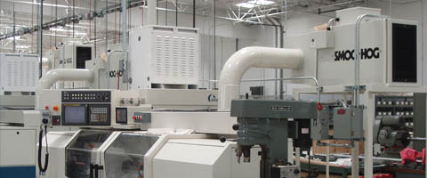

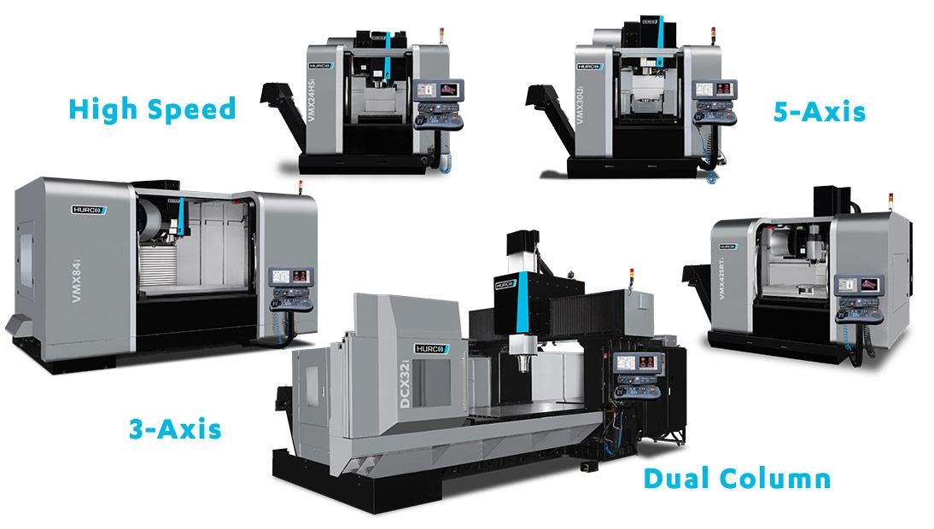

Some Industries where CNC Machining Centers are used
Here are some of the many industries where the CNC machining centers are used.
Industries for removing metal: The metal removing industries remove the metal from the raw material to give it the desired as per the requirements. These can be the automotive industries for making the shafts, gears, and many other parts. It can be manufacturing industries for making the various rounded, square, rectangular, threaded and other jobs. There are many other industries where the metal removal works are performed. All these metal removal works are performed by different machine tools like lathe, milling machine, drilling machine, boring machine, shaping machine, reamer, etc. Traditionally these machines are operated by the operators, but the CNC versions of all these machines are now used extensively. You can carryout almost all machining operations with the CNC machining centers. You can also carry out all the turning operations such as facing, boring, turning, grooving, knurling, and threading on your CNC turning centers. On your CNC grinders you can carry out the grinding of the internal diameter, outer diameter, and also the flat surfaces. The Contour Grinding technology enables you to grind surfaces of all shapes.
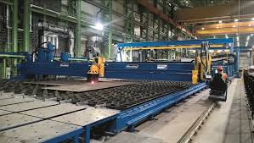
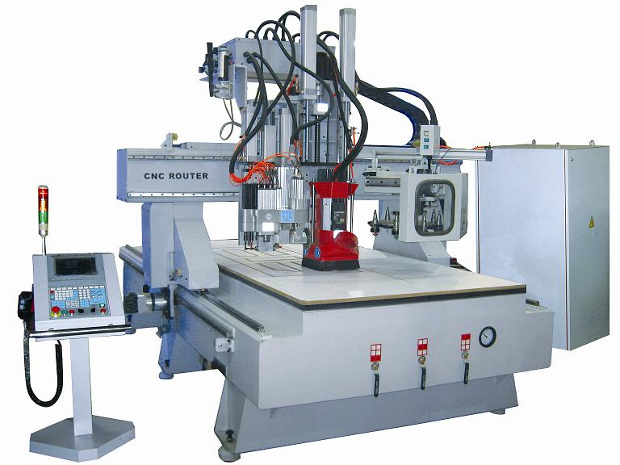

II. UNDERSTANDING THE PASSAGE
Task 1. Answer the following questions
  - What does this article describe?
…………………………………………………………………………………
…………………………………………………………………………………
  - Where are these days the CNC machines are found?
…………………………………………………………………………………
…………………………………………………………………………………
  - What should veryone involved in the manufacturing should know about ?
…………………………………………………………………………………
…………………………………………………………………………………
  - Why is there a great surge in the demand of the CNC programmers?
…………………………………………………………………………………
…………………………………………………………………………………
  - Do a number of schools teach the operation and programming of the CNC machines?
…………………………………………………………………………………
…………………………………………………………………………………

Task 2: Put a word to complete the passage
Applications, the plates, are used, machining operations, purposes
Industries for Fabricating Metals
In many industries thin plates like steel plates are required for various (1)……….., in fabrications industry the machining operations are performed on such plates. In these industries the CNC machines are used for various (2)…………….like shearing, flame or plasma cutting, punching, laser cutting, forming, and welding and many other (3)……….. To bring the plates to their final shape CNC lasers and CNC plasma cutters (4)………..commonly. To punch the holes in the plates of all sizes CNC turret punch presses are used.

III. VOCABULARY

describe (v) mô tả
industry (n) công nghiệp
scale industry(n) = industrial scale quy mô sản xuất
hardly (adv) hầu như không
facet (n) khía cạnh, mặt phẳng
touch (v) chạm, tiếp xúc
automate (v) tự động hóa
automotive (a)
automated CNC machining center
involve in (v) gồm, bao hàm
manufacturing (n) (sự) sản xuất, (sự) chế tạo
extensive (a) rộng lớn, kéo dài ra xa
surge (n) sự tràn, sự (dâng) như sống
programming (n) sự lập trình
remove (v) di chuyển
removal (n) việc di chuyển
shaft(n) (kỹthuật) trục
gear (n) sự truyền động bánh răng
thread (v) ren (đinhốc)
lathe (n,v) máy tiện, tiện
boring machine (n) máy khoan
reamer (n) (kỹ thuật) dao khoét, mũi dao
version (n) kiểu, dạng
facing (n) đối phó, (xây dưng) ốp mặt
groove (n,v) đường rãnh ( đụctrêntấmván, ….), xoi rãnh
knurl (n) vân lăn, khía ( ở kim loại), chỗ u lên
grind(v, n) nghiền, sựnghiền
grinder (n) máy xay, ngưới xay, thợmài
internal><outer ( a) bên trong><phía ngoài
diameter (n) đường kính
surface (n) bề mặt
flat (n) mặt phẳng
enable (v) làm cho có thể (làm gì)

